Jeremy Landrau
University of Advancing Technology
31 May 2026
Instructor: Professor. Tony Hinton
MS539 Programming Concepts
MAY26502

Assignment 2.2: Simulation with C#

- Due May 31 by 11:59pm
- Points 100
- Submitting a text entry box, a website url, a media recording, or a file upload
COURSE OBJECTIVES:

2. Identify the basic difference between value types and reference types.
4. Work with numeric, alphanumeric and array types.

Simulation Assignment
Overview
This assignment will require you to create a simulation of your choice
Guidelines
- Choose a SIM that you are passionate about!
I am interested in particular in having a program to have fun on that will help me better engage in the understanding and application of C# and really digging into WinForms, I think that it would also be substantially helpful to really build on the previous application that I made when I introduced and presented “Space Cowboys and Alien Thugs”, I believe that the app was rather cool and stretched my abilities a decent amount. I would like to expand by offering a different scenery which is a bit more mystical and spiritual lending to ancient Asian culture and beliefs. The simulator combines the journey of the dragon and matches it to spiritual growth and stead progression where the dragon is taking a long journey from Vietnam to Algeria, where it will journey in and out of our physical realm and the nether realm of testing the Shangri-La in order to regain strength and wisdom and get stronger. The purpose is for the dragon to arrive in the desert as a powerful being which will turn the desert “Sahara” wastelands into a beautiful and lush jungle paradise that is teaming with food, water, and life. A true oasis on earth and beacon of hope and serenity. I am passionate about spiritual and mental growth and development, and this app should hint at that, in the best way possible.
- This SIM can be as serious as you like, or for entertainment.
This sim isn’t meant to be serious but only to test again my skill and abilities at code and become humble with the process. I think that coding in general stretches my abilities and I want to fortify my progression.
- You are encouraged to use AI for ideas for your simulation. Prompt examples could be:
ChatGPT was limitedly used for this project due to lack of ability to pay for subscriptions and associated bonuses that one would find in a member or upgraded account. Since I am limited in resources in that wise, I will be able to produce what is publically available through the free app.

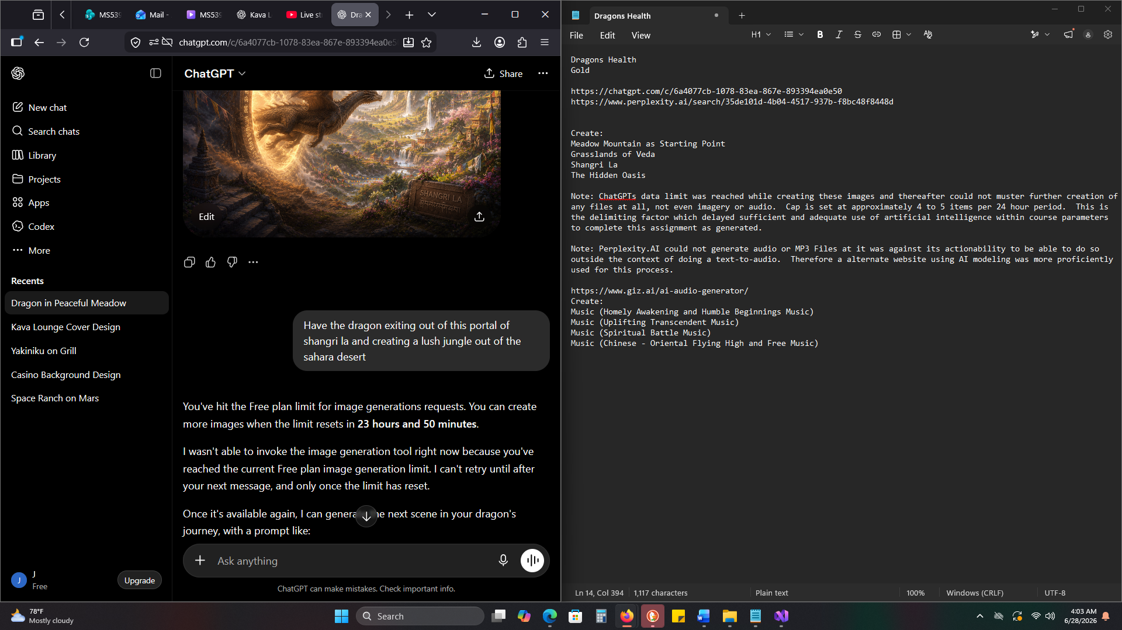

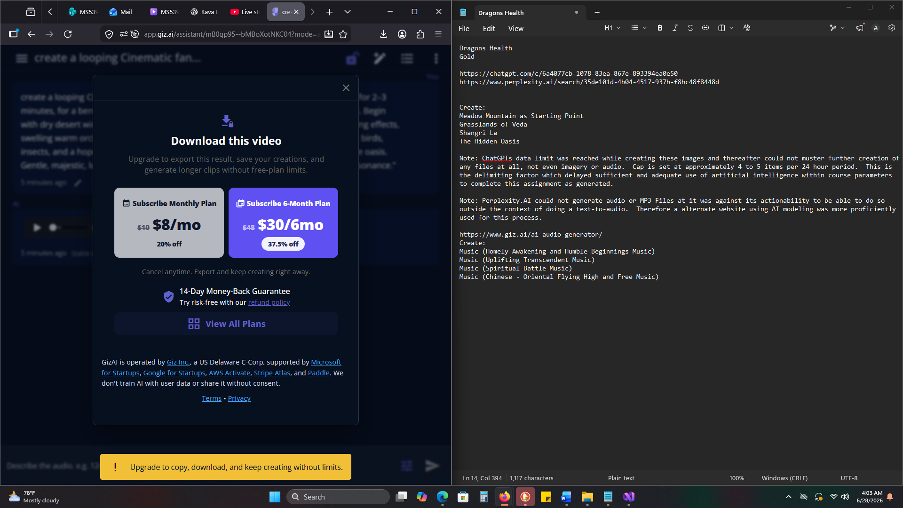

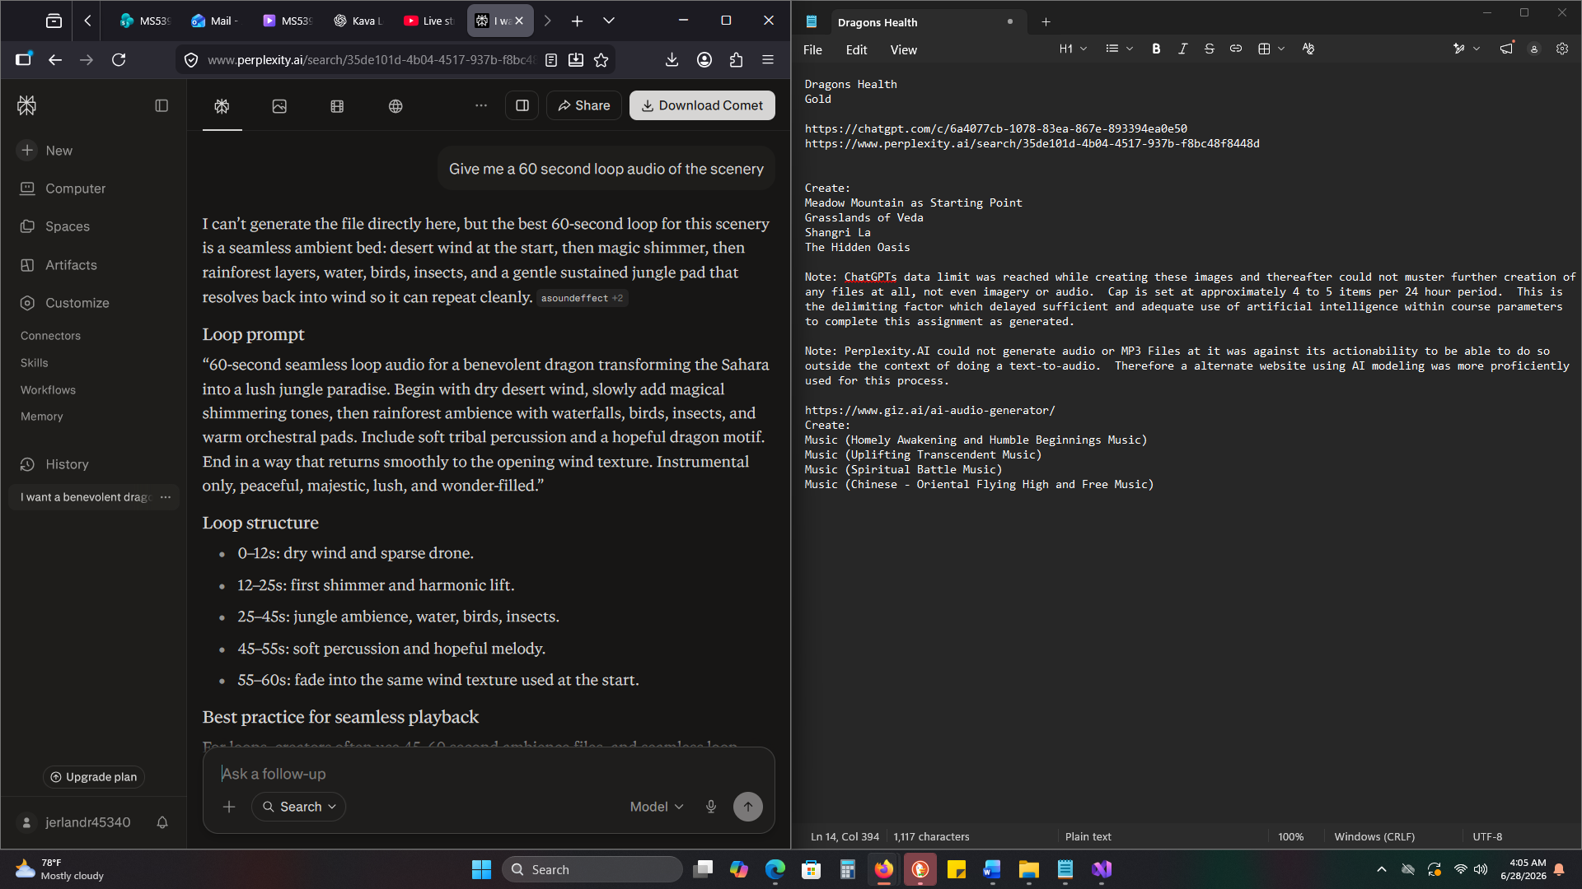
- You are encouraged to have AI write the SIM rules and text content for you, just not the code.
Text Content and the Rules were produced by me as I am albeit on the tech averse side of things and would rather conceptualize by hand and mind more than relying on computers or artificial intelligence.
- You are encouraged to have AI generate some UI designs, not UI code to look at and emulate.
Images Generated by A.I. which are enclosed in the presented files, documents, and repository as well as in the video presentation.
- Unless you have asked me, please use the VS 2022 or VS 2026 Community edition IDE.
VS 2026 in the most upgraded version possible was used for this Assignment and Project script without reservation.

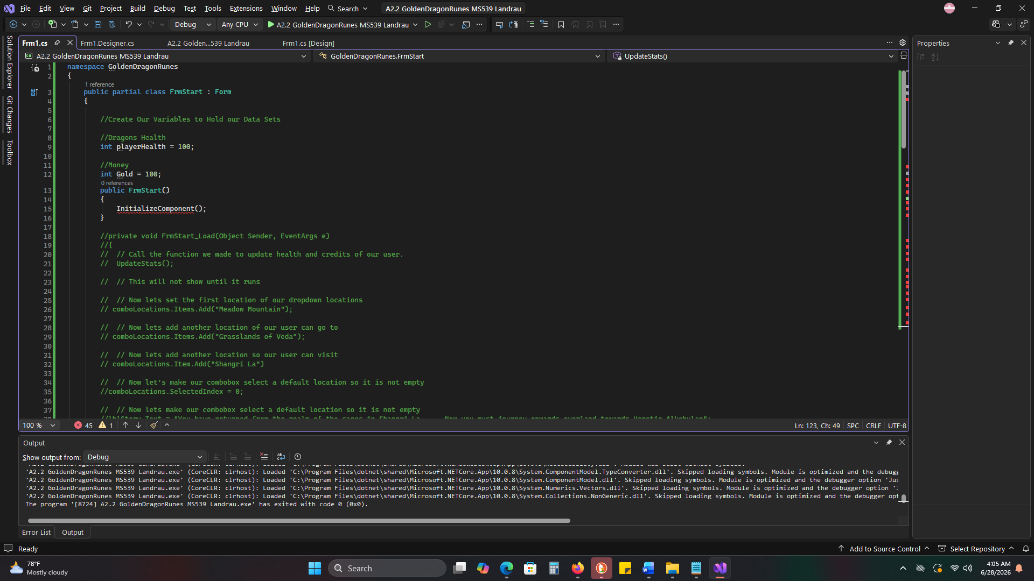

Requirements and Expectations

- Pick a purpose for your Simulation
To remind, inspire, and really uproot the wonders of the imagination and creativity of the onlooker as well as be the premise for anyone using to question more and deeper about their spiritual and emotional essences and states of being.



- Use WinForms and C# to code a GUI Simulation with support code.
As Presented
- Your Sim should be simple and feel complete.
- Your SIM should have a great User Experience and UI.
Upon testing the application, the major issue that I would still find which has been discussed several times over is the progressions and transitions of scenery. I would want to make the application really slow it down so that way the user can have a more pleasing and uplifting experience through the art presented as well as be able to mentally visualize themselves as being within the applications settings.
- Your SIM should be easy to understand.
- Your SIM should have a clear purpose.
- Your Code should be overcommitted.
Deliverables and Submission
- Create a YouTube link that showcases your app from a user's perspective.
As Presented:
- A GitHub link to your repository containing your code.
As Presented:
- You must be speaking and demoing your app.
As Presented:

